Investigating Photosynthesis
Name: ______________________________________________________
Q1. In the seventeenth century a Belgian scientist, Van Helmont, planted a young willow tree in a tub of dry soil.
During the next five years he watered the plant with rain water but he did not add anything else to the tub.
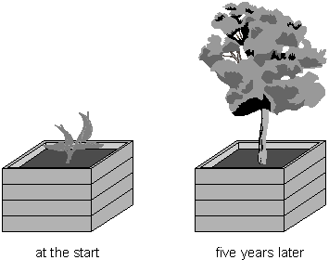
not to scale

After five years Van Helmont removed the willow tree from the tub and weighed the tree.
He also dried and weighed the soil. Results from Van Helmont’s experiment are shown in the table.

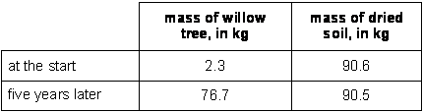

(a) Van Helmont concluded that the increase in the mass of the willow tree was due only to a gain in water.
(i) What two pieces of evidence did Van Helmont use to reach his conclusion?
…………………………………………………………………………………
……………………………………………………………………………
…………………………………………………………………………………
…………………………………………………………………………………
2 marks

(ii) We now know that Van Helmont’s conclusion is not correct.
Explain why the mass of the willow tree increased by such a large amount.
… ………………………………………………………………………………
…………………………………………………………………………………
…………………………………………………………………………………
…………………………………………………………………………………
…………………………………………………………………………………
2 marks

(b) Van Helmont believed that a plant would always grow faster if it was given more water.
We now know that this is not true.
Give two environmental conditions which can slow down the growth of a plant, even when it has plenty of water.
1. … ….………………………………………………………………………………
……….………………………………………………………………………………
2. … ….………………………………………………………………………………
……….………………………………………………………………………………
2 marks

(c) The fresh mass of a plant includes water. To measure plant growth accurately, scientists calculate the increase in the dry mass rather than the increase in the fresh mass of a plant.
Why is finding the increase in fresh mass not a reliable way to measure plant growth?
…… ….………………………………………………………………………………
……….………………………………………………………………………………
……….………………………………………………………………………………
1 mark
Maximum 7 marks

