Task 1

- Write down one function (job) of the upper and lower epidermis.
- What is the name of the green structure inside a plant cell that can catch light energy to allow the plant to make food?
- Which two types of plant cells in the leaf can make food?
- Why is it important that the upper epidermis cells are thin and transparent (colour less)?
- Why is it important that the palisade cells are near the top of the leaf?

Task 2- Looking at the Food factories – The leaf

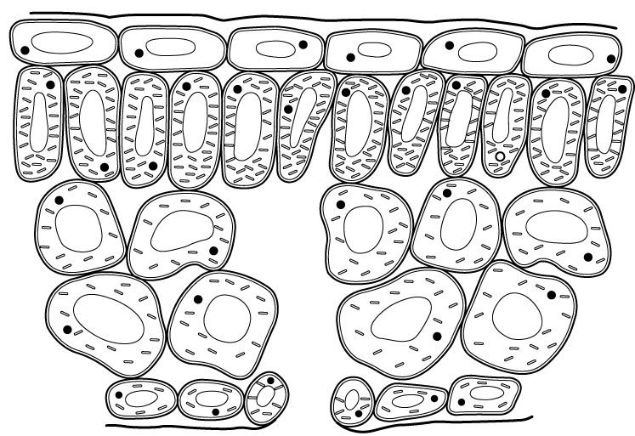

------------------------------------------------------------------------------------------------------
The air holes are found on the bottom of the leaf. They let carbon dioxide in and oxygen out.
The waxy layer at the top of the leaf stops the leaf from drying out and losing water.
The lower epidermis cells are a layer at the bottom of the leaf which act like a ‘skin’.
The spongy cell layer can catch any light the palisade cell layer misses. They are rounded cells.
The palisade cell layer catches the most sunlight because the cells are tightly packed together.
The upper epidermis is a clear layer of cells at the top of the leaf that act a bit like a ‘skin’.

