BPS Performing Arts Project
Year 9

Name:__________________________________________

Task 1: Stage Positions
Label the stage positons in their correct boxes.

Centre stage Stage Left Stage Right Upstage Centre
Downstage Centre Upstage Right Upstage Left Downstage Right
Downstage Left
9.
10.

/10
Area for improvement:
Task 8: Stage Configurations
1. The name for this stage type is
a) Theatre in the round
b) Thrust staging
c) Promenade

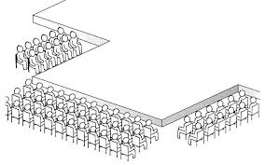

2. The name for this stage type is
a) Theatre in the round
b) Thrust staging
c) Promenade
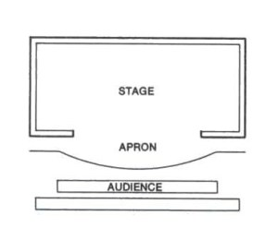

3. The name for this stage type is
a) Theatre in the round
b) Thrust staging
c) Promenade

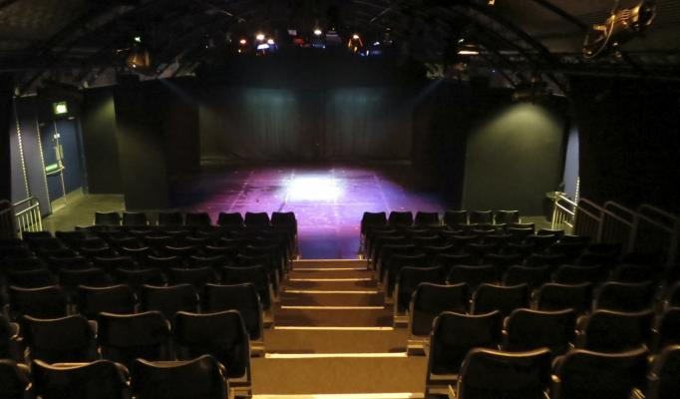
4. The name for this stage type is
a) Theatre in the round
b) End on
c) Promenade

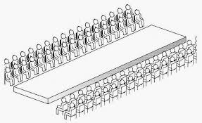

5. The name for this stage type is
a) Traverse
b) End on
c) Promenade

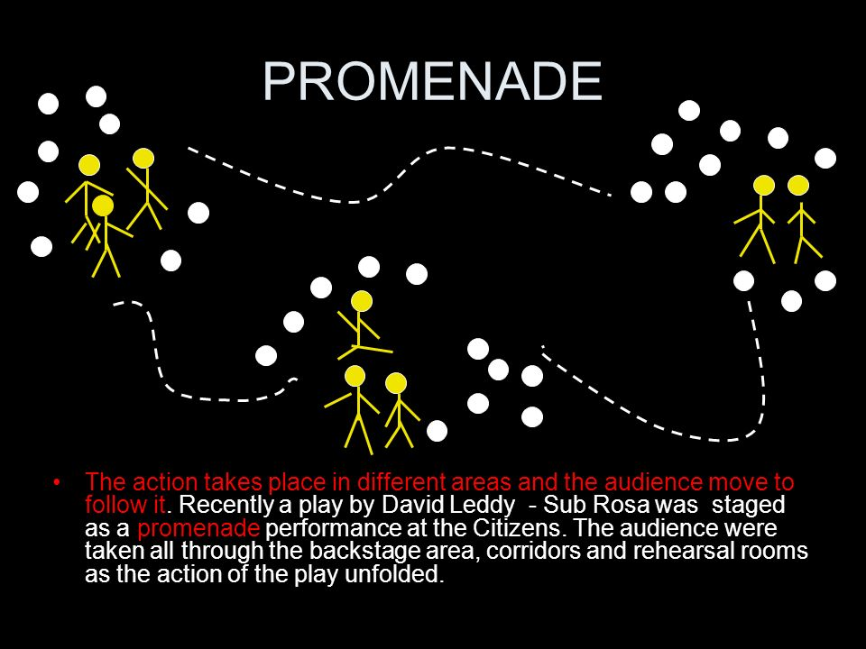
5. The name for this stage type is
a) Traverse
b) End on
c) Promenade

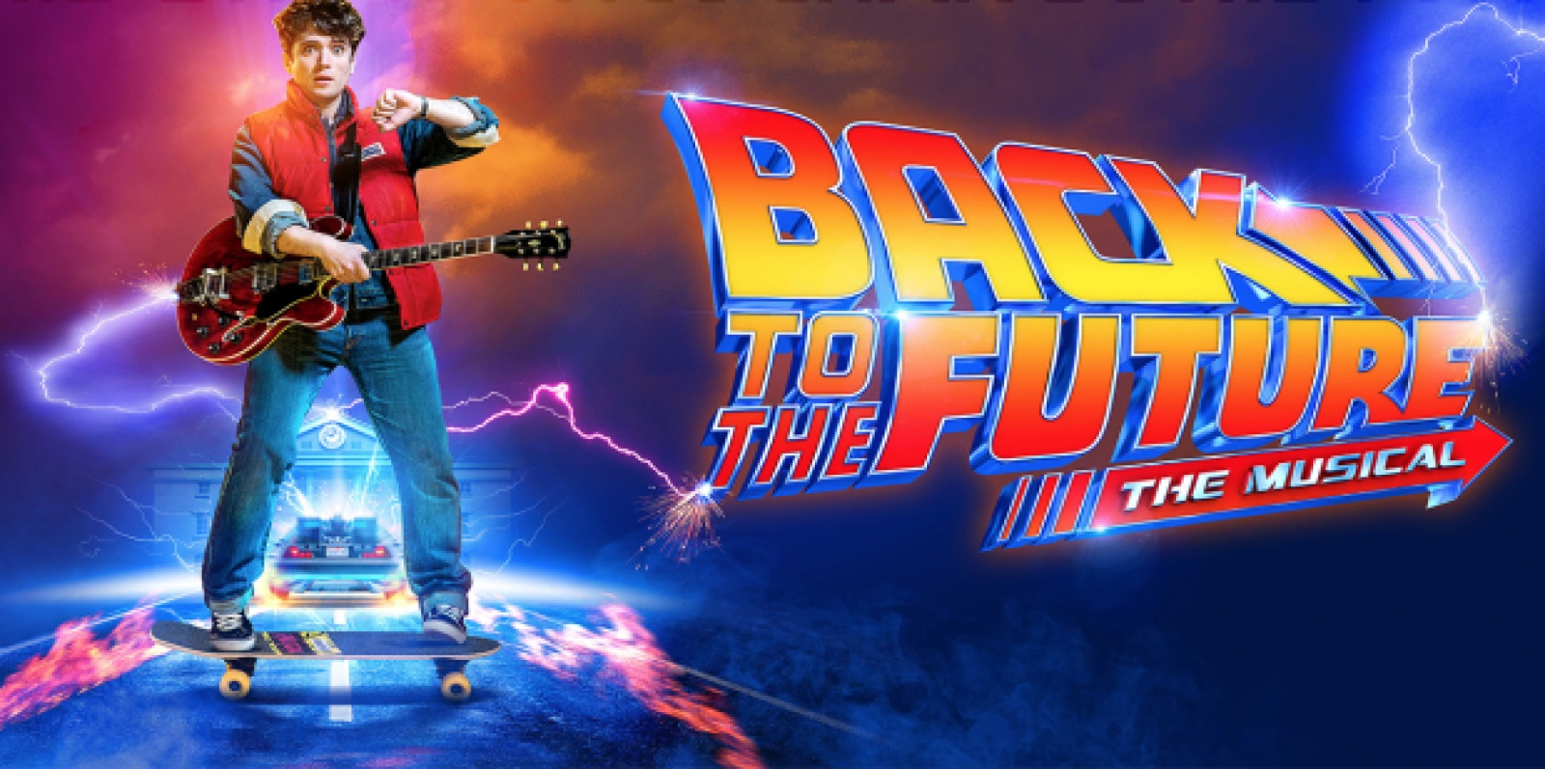
You are working for a Musical Theatre Marketing and Design Company and you have received the following email off Cameron Mckentosh regarding the opening of his new show
“BACK TO THE FUTURE THE MUSICAL”
which is based on the film of the same name.
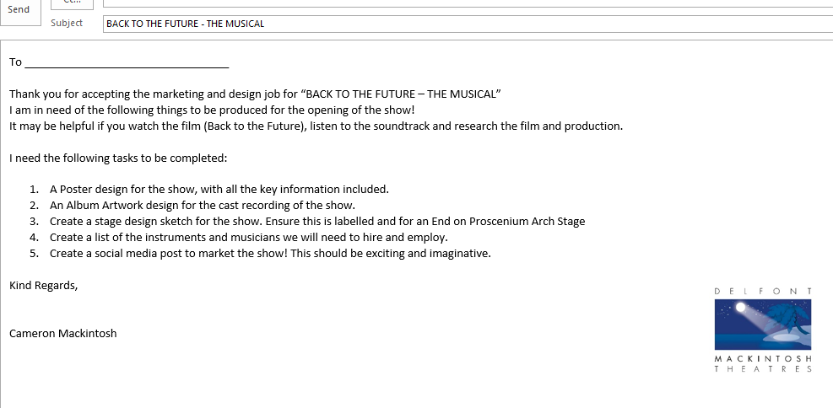
Key Information

VENUE:

MANCHESTER OPERA HOUSE
Quay St, Manchester M3 3HP
SHOWTIME:

Doors 7pm
Show 7:30pm
(Mon-Sat)
Matinee 2:30pm (Wed & Sat)

Tickets Priced Between: £10-£50

Track List
- It's Only a Matter of Time
- Wherever We're Going
- Hello - Is Anybody Home?
- It Works
- Cake and Eat It Too
- Good at Being Bad ¹
- Gotta Start Somewhere
- My Myopia
- Pretty Baby
- Future Boy
- Hill Valley High School Fight Song
- Something About That Boy

- Use this page to design a poster- using the information on the previous page.

- Create the Album Artwork, be sure to include the track list on the back.

FRONT

BACK

3. Turn this page landscape and design your stage.

5. Design your Social Media posts.
