Lesson 3 Science Analysing Distance Time Graphs

1. A game of golf.
The distance–time graph shows the journey of a golf ball from the tee to the hole.
Use the graph to answer the following questions.
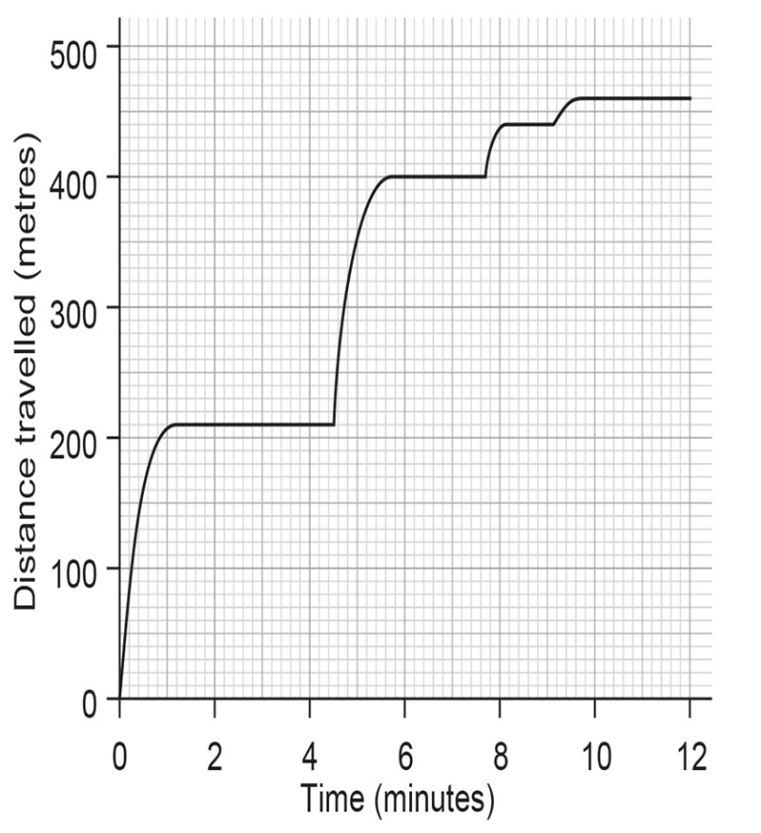
a) How many shots did the golfer take? ………………….
b) What was the total distance travelled by the ball? ………………….
c) How far did the golfer’s longest shot go? ………………….
- Four sections of the graph are curved rather than straight. Explain what this shows.
………………………………………………………………………………………………………………………..
………………………………………………………………………………………………………………………..
………………………………………………………………………………………………………………………..
………………………………………………………………………………………………………………………..

2. The graph shows the journey of two cars from their home.
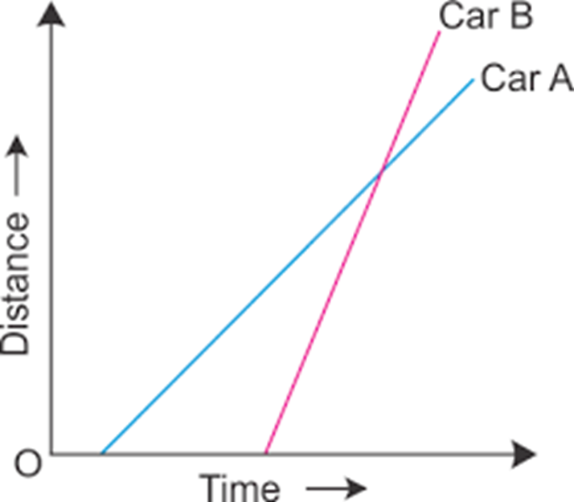
Answer the following questions about the cars.

- Which car set off from the house first?
……………………………………………………………………………
b) Which car travelled the fastest?
……………………………………………………………………………
c) Which car arrived at the destination first?
……………………………………………………………………………
d) Did both cars arrive at the same destination? How do you know this from the graph?
……………………………………………………………………………………………………………………………..
……………………………………………………………………………………………………………………………..
e) Did the speed of Car A change at all during the journey? How do you know this from the graph?
……………………………………………………………………………………………………………………………
……………………………………………………………………………………………………………………………

