Lesson 4 Science – Velocity and Relative Motion
Challenge 1
Two cars are approaching each other. One is travelling at 30 mph whilst the other is travelling at 50 mph.
What is their relative speed?
Challenge 2
Cars travelling in the same direction >
The diagrams show two cars travelling along a road in the same direction. The cars are travelling at different but constant speeds. Picture 2 is taken 10 seconds after picture

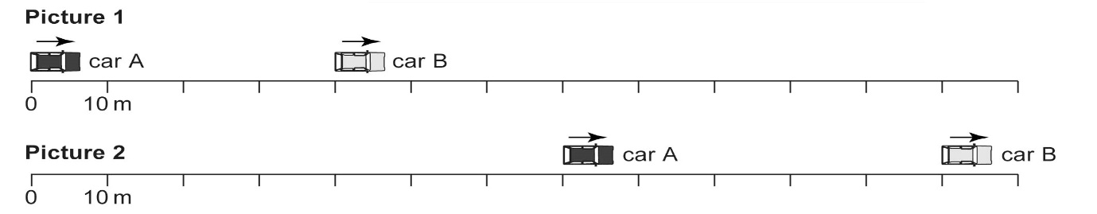

a) How far has each car travelled between picture 1 and picture 2?

b) Calculate the speed of each car in m/s.

c) What is the relative speed of the two cars?

d) How far apart will the two cars be after a further 5 seconds has passed?

e) Add a third car to the diagram above, which starts 10 m ahead of car A, but travels at half the speed of car A.

