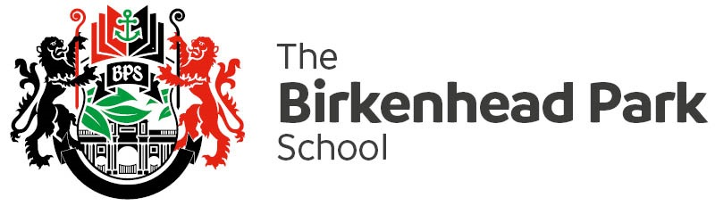

Ref MEE/Dbe

February 2019

Dear Parent/Carer

In order to prepare our Year 11 students for the rigour and challenges of the full GCSEs we have planned a final Mock examination week beginning **Monday 11 March.**

These final Mock examinations are a crucial part of Year 11 students’ preparation for their final GCSEs and they should be approached with a similar degree of ambition, seriousness and effort. They should be revising for at least 2 hours per day and act upon advice and guidance given to them by their subject teacher.

Please support us in ensuring your child is fully prepared for these exams, a copy of the Year 11 Mock Examination timetable is on the reverse of this letter.

Yours sincerely



Peter Mee

Deputy Headteacher

