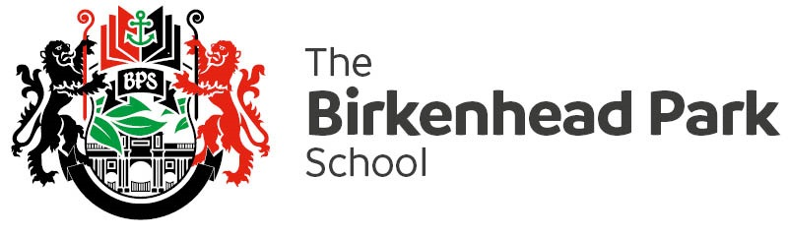

Ref MEE/Dbe

February 2019

Dear Parent/Carer

Students in Year 7 – 10 will sit their end of learning programme examinations during the week beginning **Monday 4 March.**  These examinations will give teachers the opportunity to accurately assess their attainment and progress.

All students should approach these examinations with the ambition and resilience to do their best and they must prepare thoroughly, it is essential that they take the time to revise in order to achieve their potential. Examinations will take place during their normal timetabled lessons, although some subjects may set more than one paper for students to complete and spread the examination over a number of lessons.

Please support us in ensuring your child is fully prepared for these examinations and arrive to school on time with the necessary equipment.

Yours sincerely

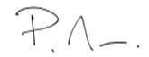

Peter Mee

Deputy Headteacher

